CoalFire Terraform Project

Resources Used
- Docs overview | hashicorp/azurerm | Terraform | Terraform Registry
- Visual Studio & VS Code Downloads for Windows, Mac, Linux
- PowerShell
- Github
- Azure Portal
- Cloud Services Azure Technical Challenge

Why HashiCorp for this project?
- I used HashiCorp Configuration Language (HCL) for this project. Instead of choosing to go with CoalFires Open Source they provided, since it has been some time working within Terraform, I decided to use all of the code provided directly off of the HashiCorp website.
- Why I chose to use HCL for this project:
- Terraform uses HCL, a declarative language designed for infrastructure as code
- Benefits of HCL: Human-Readable syntax- Easy to understand and maintain, Declarative approach- Focus on desired state rather than procedural steps, Extensible- Supports modules, variables, and reusable components, and works seamlessly across multiple cloud platforms.
- Why is this a good resource?
- Industry standard for IaC
- Strong community support and documentation
- Enables automation, consistency, and scalability in cloud deployments.

Project Files Explained
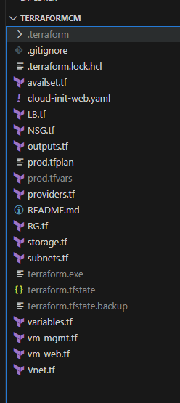
Core & Environment Files
- providers.tf
Declares the AzureRM provider (and any others), config settings (e.g., features block), and optionally provider version constraints.
Why: Central place to control provider versions and authentication method (e.g., Azure CLI, Workload Identity, service principal).
- variables.tf
Defines input variables (name, type, description, defaults) used by your configuration.
Why: Makes your code configurable and reusable across environments (e.g., location, resource names, CIDRs).
- outputs.tf
Exposes useful values after terraform apply—like public IPs, resource IDs, or URLs.
Why: Quick discovery and integration points for automation or documentation.
- prod.tfvars
Your environment-specific values for variables (e.g., resource group name, location, CIDRs, admin usernames, cloud-init path).
Why: Keeps environment overrides separate from generic defaults—so you can run -var-file="prod.tfvars" to target “prod” cleanly.
- prod.tfplan (optional binary/JSON plan you saved)
A serialized plan output from terraform plan -out=prod.tfplan you can later apply with terraform apply prod.tfplan.
Note: You typically don’t commit plan files to Git—they’re ephemeral and environment-specific.
- .terraform.lock.hcl
The dependency lock file pinning exact provider versions used in your last init.
Why: Ensures consistent provider versions across machines/CI runners (you do commit this).
- .terraform/ (folder) & terraform.exe
Local working directory that holds downloaded providers & state hooks; terraform.exe is the CLI binary.
Best practice: Don’t commit .terraform/ or the Terraform binary—add them to .gitignore.
- terraform.tfstate, terraform.tfstate.backup
Local state tracking real-world resources.
Best practice: Do not commit state. Prefer remote state (e.g., Azure Storage) with state locking to avoid drift and conflicts.
- .gitignore
Ensures sensitive or generated files are excluded from Git (e.g., .terraform/, state, local tfvars with secrets, SSH keys, plan files).

Network & Infra Building Blocks
- RG.tf
Creates the Resource Group that holds all your Azure resources.
Why: Single place to name and tag your deployment boundary.
- Vnet.tf
Defines the Virtual Network (VNet)—address space, DNS settings if any.
Why: Network backbone for subnets and security boundaries.
- subnets.tf
Declares subnet(s) like subnet_mgmt and subnet_web, with CIDR ranges and optional delegation/service endpoints.
Why: Logical segmentation (mgmt vs web) and policy application via NSGs/UDRs.
- NSG.tf
Creates Network Security Groups and rules:
  - Mgmt NSG: allow SSH from trusted CIDR; deny all else.
  - Web NSG: allow HTTP from AzureLoadBalancer and SSH only from mgmt; deny all else.
Why: Enforces least privilege at subnet level.
- LB.tf
Defines Load Balancer, frontend IP, backend pool, health probes (HTTP/80), and LB rules.
Why: Distribute traffic to web VMs; health probe is why the NSG allows AzureLoadBalancer on 80.
- availset.tf
Creates an Availability Set for VMs (fault/update domains).
Why: Improves resilience against host failures when not using VMSS.
- storage.tf
Any Storage Account or disks you provision (possibly for boot diagnostics, logs, or data).
Why: Centralized storage resource with proper SKU and access controls.
Compute
- vm-mgmt.tf
Provisions the management VM (Ubuntu 22.04 per your SSH transcript).
  - Injects SSH public key, sets admin_username.
  - Attaches NIC to mgmt subnet/NSG.
Why: Secure admin box for operations and testing (and SSH jump host if needed).
- vm-web.tf
Provisions web VM(s) and sets:
  - custom_data = filebase64(local.cloud_init_web_path)
  - NIC to web subnet/NSG & LB backend pool.
Why: Bootstraps Apache and a test page via cloud-init and integrates with LB.
- cloud-init-web.yaml
Cloud-init for web VMs to install Apache, enable service, and write a simple HTML page.
Why: Idempotent first-boot configuration without manual SSH provisioning.

.tfvars Terraform file, explained

Why I used the prod.tfvars file.
- Separation of concerns: Keeps environment-specific values out of generic defaults.
- Reusability: You can run dev.tfvars, test.tfvars, prod.tfvars with the same codebase. (For this project because of time, I chose to only include the prod.tfvars file) Other projects I would create the dev.tfvars file for testing purposes.
- Repeatable workflows: terraform plan -var-file="prod.tfvars" and terraform apply -var-file="prod.tfvars" become standard ops.
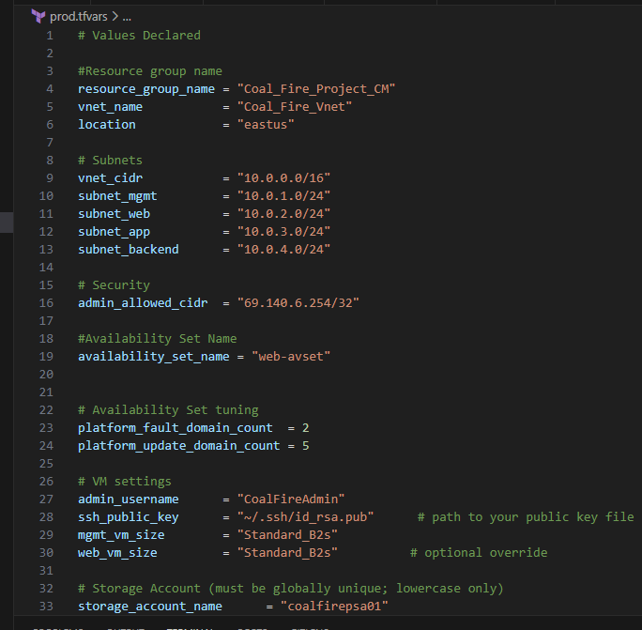

Best Practices for .tfvars
- Environment-specific files
- I could use these specific files and break it up: dev.tfvars, test.tfvars, prod.tfvars. Never hardcode environment values in variables.tf.
- Secrets handling
  - Prefer environment variables (TF_VAR_...) or a secrets manager (Azure Key Vault) over storing secrets in .tfvars.
  - If you must store non-critical secrets locally, name the file something like local.secrets.tfvars and gitignore it.
- Consistent naming & tagging
Capture naming conventions (prefixes/suffixes) and tags in .tfvars for consistent resource naming and governance.
- Do not commit sensitive .tfvars
Add patterns to .gitignore
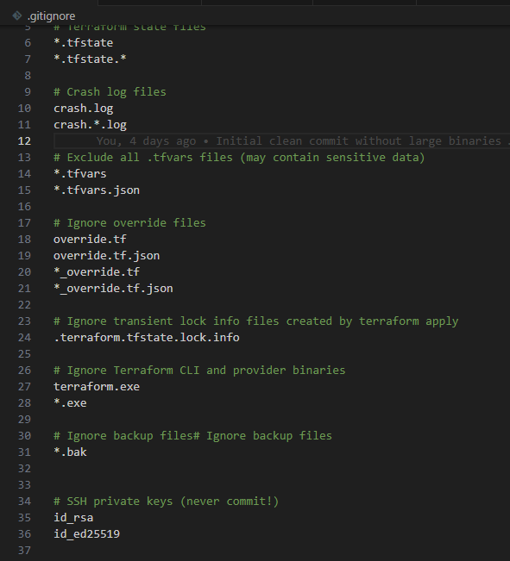

SSH Keys Explained
- Generated a 4096-bit RSA key locally (id_rsa + id_rsa.pub) via PowerShell.
- Configured Windows ssh-agent and added the private key with ssh-add, so the key isn’t read from disk by Git processes.
- Only the public key was referenced by Terraform (e.g., ssh_public_key = "~/.ssh/id_rsa.pub" in your .tfvars or locals).
- Did not commit id_rsa or any private key file to GitHub—protected by .gitignore patterns and good hygiene (See screenshot above for my .gitignore file.

